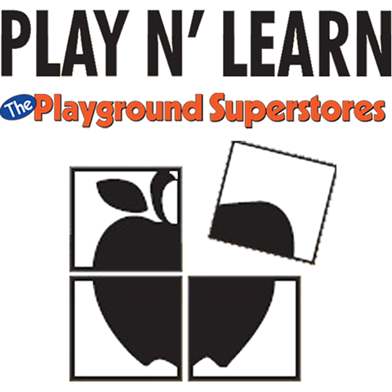
Play For Charity Fundraiser
At
Play N’ Learn The Playground Superstores
9033 Red Branch Road
Columbia, MD 21045
&

4102 Pepsi Place

Chantilly, VA 20151

$8.00 per child

Thursday, July 27, 2017 10:00 am – 12:00 pm
Come join us for a day of fun where 100% of all the proceeds will be
Donated to WLCN!
Enjoy the playsets, trampolines, basketball courts, & more!

